<New Lands> - Workplace Ergonomics

# Third Party Applications

**Trello**

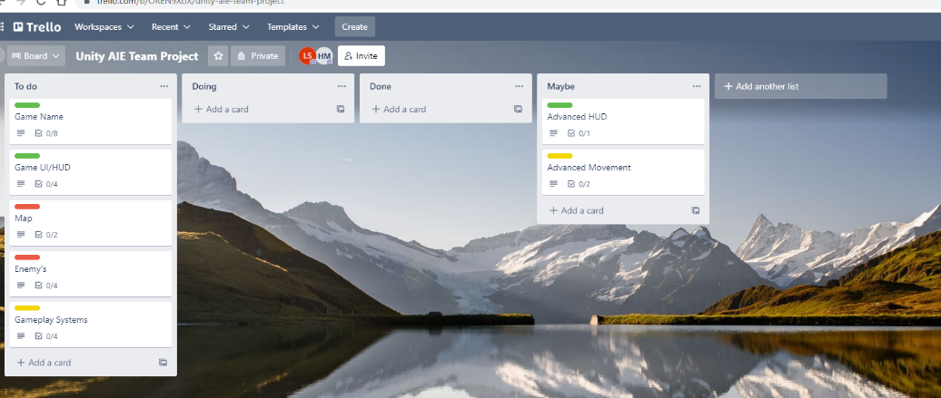

**GitHub**

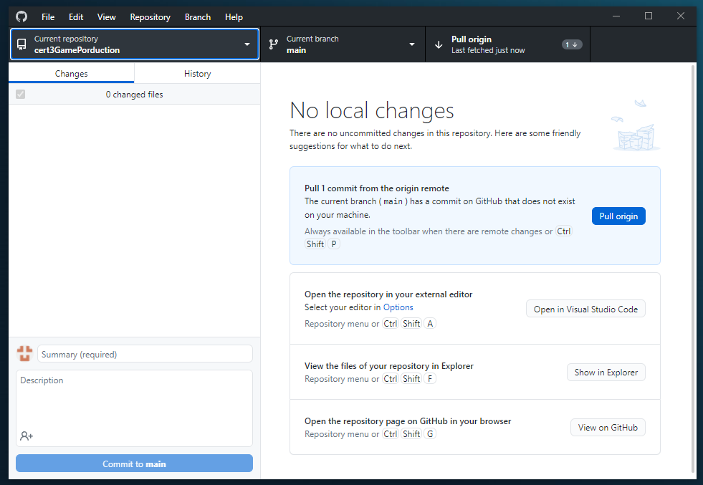

**BitBucket**

# Operating System Settings

**Photos of OS settings**

# Furniture Adjustments

**Photos of cable, chair, monitor and keyboard setups**